Date:18/08/2022



LabSessionNo.:05

Task 5:Design a test case for parameterized testing for PrimeNumber using JUNIT

**Task 5:** Parameterized testing using Junit

**Aim:** To perform parameterized testing using JUnit.

**Procedure:**

**Steps:**

1. Creating Java project.

* Click on File and select New project
* Enter project name as com.Junit.Prime_arm
* Click on Next and then on Finish

2. Creating java Test Project

* Right click on com.Junit.Prime_arm
* Click on properties and select tab java build path
* Click on source and click on Create New Folder.
* Give the folder name as Test and click on next.
* Click on Finish and then on OK

3. Creating java class

* Right click on com.Junit. Prime_arm and click on New .
* Click on class and give the class name as Prime_arm
* Click on Finish
* Type the following code

**package** com.Junit.Prime_Arm;

**public** **class** Prime_arm {

**public** **boolean** prime(**int** n) {

**if**(n==1)

**return** **false**;

**else** **if**(n==2)

**return** **true**;

**else** {

**for**(**int** i=2;i<n;i++) {

**if**(n%i==0)

**return** **false**;

}

**return** **true**;

}

}

**public** **boolean** armstrong(**int** n) {

**int** pow=String.*valueOf*(n).length();

**int** temp=n;

**int** sum=0;

**int** r=0;

**while**(n>0) {

r=n%10;

sum+=Math.*pow*(r, pow);

n/=10;

}

**if**(sum==temp)

**return** **true**;

**return** **false**;

}

**public** **int** check_prime_arm(**int** n) {

**if**(prime(n))

**return** 1;

**if**(armstrong(n))

**return** 2;

**return** 0;

}

}

4. Create java test class

* Right click on com.Junit.Prime_arm and click on new
* Click on Junit test case.
* Change the name of folder src to test in source folder tab.
* Click on browse and select Prime_arm class and click on Next.
* Click on Finish and then on OK.
* Add the following code

**package** com.Junit.Prime_Arm;

**import** **static** org.junit.Assert.*;

**import** java.util.Arrays;

**import** java.util.Collection;

**import** org.junit.Test;

**import** org.junit.runner.RunWith;

**import** org.junit.runners.Parameterized;

**import** org.junit.runners.Parameterized.Parameters;

@RunWith(Parameterized.**class**)

**public** **class** Prime_arm_test {

**int** n;

**int** res;

**public** Prime_arm_test(**int** n,**int** res) {

**this**.n=n;

**this**.res=res;

}

@Parameters

**public** **static** Collection<Integer[]> check_prime_arm(){

**return** Arrays.*asList*(**new** Integer[][] {{2,1},{3,1},{153,2}});

}

@Test

**public** **void** test() {

Prime_arm pa=**new** Prime_arm();

System.***out***.println("Checking the number "+n);

*assertEquals*(res,pa.check_prime_arm(n));

}

}

**Output:**

**Pass case for Prime_arm:**

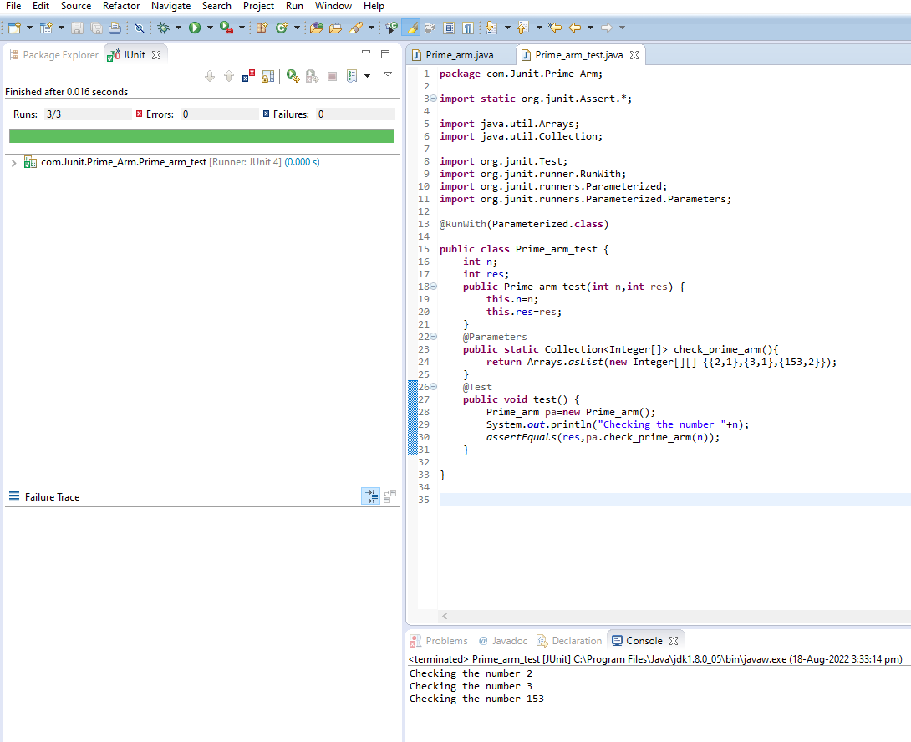

**Fail case for Prime_arm:**

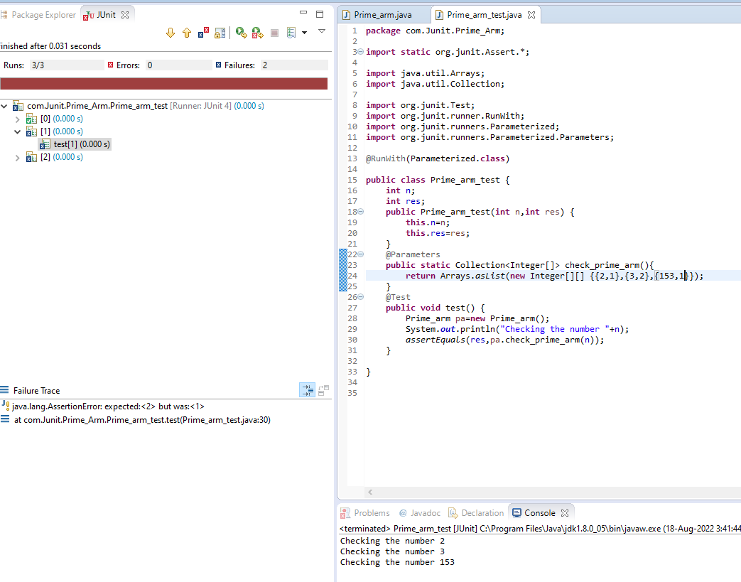

**Evaluator’sObservation**

**MarksSecured: outof**

**FullNameoftheEvaluator: Student’sSignature**

**Signatureofthe Evaluator: DateofEvaluation:**